VISHAL DILIP DIWAN
Data Engineer and Development
Vishaldiwan153@gmail.com
7378342898
OBJECTIVE

To work in high-grown organization with a competitive and challenging environment that creates an ideal condition for delivering high quality services.

SUMMARY

- Better knowledge of writing different DML, DDL & DCL statements.
having sound knowledge of Single row & multiple row sub-queries.
- Good Hands-on experience on writing Joins, Subqueries, Set Operators.
- Good knowledge in Oracle advance SQL programming using Analytical functions, Group Functions, Sub Queries, Indexes, and Set Operators.
- Knowledge in Stored Procedures, Triggers, functions using PLSQL.
- Hands-on Python.

- Good knowledge about Python Data types, Conditional statements, Loops. Sound knowledge of List, Tuple, Dictionary, String, Arrays
- Good knowledge of OOPS concept in python
- Good Knowledge of EXCEL.
- Hands-on ETL (Extract Transform Load) tool.
- Hands-on Visualization tools are Power-bi, Tableau and smarten etc.

TRAINING & CERTIFICATION

Business Intelligence from Catalyst IT
Duration: Feb 2022 – Completed.

WORK EXPERIENCE:
Data Analytics and Developer
ClapTek Private limited (Mumbai)
May 2022 – Feb 2024
- I had worked on Audit Analytics Assignment projects with oracle SQL developer TCL and python List, tuple and Dictionary in client requirement (ADCC).
- I had worked in DMA (data migration audit) in ORACLE SQL developer with help Extract transform load (ETL).
- I had worked in E-Mail configuration developed in ORACLE and SQL Server with procedures in multiple clients.
- I had worked in AXIS Bank project done with charges part in the project in SQL complex query’s.
- I had worked in Aditya Birla finance Ltd project on processing fees in SQL complex query’s.
- Find out all of exceptions reports in client data in filtering and conditions pipelined through millions
- I had worked with development in python using inheritance, polymorphism, encapsulation and abstraction.
- I had worked on Procedures, functions, cursors and triggers, table functions and pipeline functions in oracle.
- Hands-on ETL (Extract transform load) tool.
- I had worked in multiple clients like

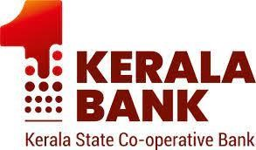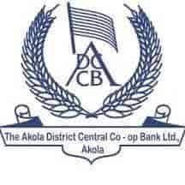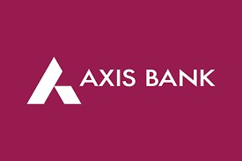

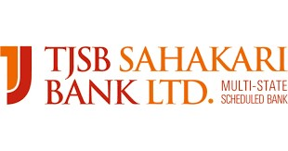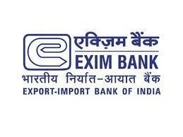

Advisor Outbound Sales
Reliance SMSL Limited (Thane)
April 2021 – Feb 2022
- Successfully conducted network maintained and troubleshooting to ensure smooth operations of telecommunications system.
- Installed and maintained, such as telephone systems, Jio fiber optics and microwave radio systems.
- Performed routine inspections and maintenance of telecommunication equipment and systems

EDUCATION

BSC (Computer Science)
University of Pune
Jun 2017 – Jully 2020

SKILLS:

- SQL (Oracle, SQL Server)
- Python
- ETLs
- PLSQL (Oracle, SQL Server)
- Microsoft EXCEL
- AWS (Athena, Lambda, S3)

DECLARATION

I hereby declare that, the above-mentioned information is true to the best of my knowledge.

PLACE: Pune Vishal Diwan

